**API of DMA**

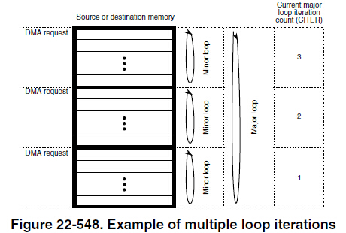

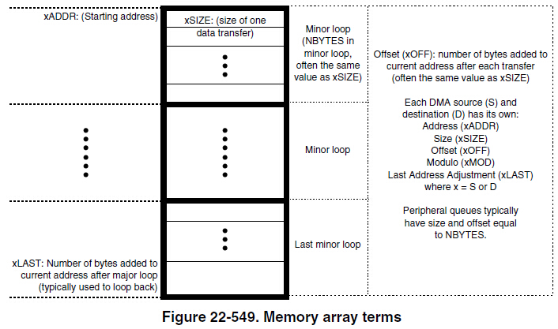

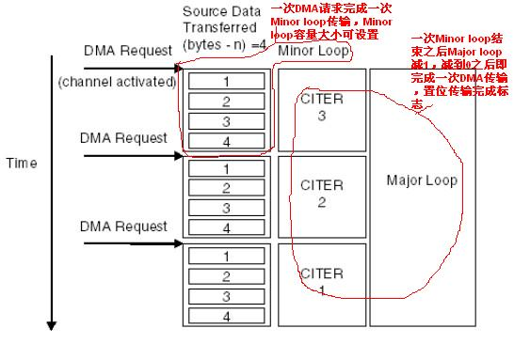

**/************************** 函数定义 ******************************/**

**void DMA_Clear_Int(**uint8 **CHx);**

**void DMA_Init(**uint8 **DMAMUXx,** uint8 **CHx,** uint32 **Source,**uint8 **Mode);**

**void DMA_Source(**uint8 **CHx,** uint32 **Src_Addr,**int32 **Src_AddrOffset,** uint32 **Src_DataSize,** int32 **Reset_Src_Addr);**

**void DMA_Destination(**uint8 **CHx,** uint32 **Dest_Addr,**int32 **Dest_Addr_Offset,** uint32 **Dest_DataSize,** int32 **Reset_Dest_Addr);**

**void DMA_Int_Enable(**uint8 **CHx,** uint32 **Int_Type);**

**void DMA_Int_Disable(**uint8 **CHx);**

**void DMA_AutoClose_Enable(**uint8 **CHx);**

**void DMA_AutoClose_Disable(**uint8 **CHx);**

**void DMA_Major_Loop_Num(**uint8 **CHx,** uint16 **Cycles);**

**void DMA_Minor_Bytes(**uint8 **CHx,** uint16 **Bytes);**

**void DMA_Software_Initiate(**uint8 **CHx);**

**void DMA_Enable();**

**void DMA_Disable();**

**void DMA_Debug_Enable(**uint8 **CHx);**

**void DMA_Debug_Disable(**uint8 **CHx);**

**void DMA_Set_Group_Priority(**uint8 **CHx,** uint8 **Group0_Priority,** uint8 **Group1_Priority);**

**void DMA_Set_Channel_Priority(**uint8 **CHx,** uint8 **Priority);**

uint8 **DMA_Get_Channel_Priority(**uint8 **CHx);**

uint8 **DMA_Get_Group_Priority(**uint8 **CHx);**

**/**************************** END of函数定义******************************/**

**/***************************** 函数功能介绍 ******************************/**

**DMAMUX0对应着通道0~15**

**DMAMUX1对应着通道16~31**

**void DMA_Clear_Int(**uint8 **CHx);**

功能:清除中断标志位,用于中断服务函数的第一句

**参数: CHx: DMA_CH0**~**DMA_CH31**//选择通道0~31

**void DMA_Init(**uint8 **DMAMUXx,** uint8 **CHx,** uint32 **Source,**uint8 **Mode);**

**功能:**选择通道,触发源,是否周期性触发

**参数: DMAMUXx:**  **DMAMUX0,DMAMUX1**

**CHx: DMA_CH0**~**DMA_CH31**//选择通道0~31

**Source:** //选择触发源,触发源放在DMA.h文件

**Mode: DMA_Normal_ModeDMA_Periodic_Mode**

//是否选择周期触发模式

**void DMA_Source(**uint8 **CHx,** uint32 **Src_Addr,**int32 **Src_AddrOffset,** uint32 **Src_DataSize,** int32 **Reset_Src_Addr);**

**功能:**选择通道

输入源数据的地址

**有符号**的源地址偏移.配置源数据地址偏移，即每执行完一次**Src_DataSize**的传输就对源数据地址进行偏移**Src_Addr_Offset**个字节

源数据类型的字节长度,**8BIT,16BIT,32BIT,16BYTE**

**有符号**的源地址最终偏移.主的计数次数（major iteration count）减到零后，重新调整源地址,原来的源数据地址的偏移

**参数: CHx: DMA_CH0**~**DMA_CH31**//选择通道0~31

**Src_Addr:**  源数据的地址,注意是否需要地址符**&**

**Src_AddrOffset: 有符号**源地址偏移

配置源数据地址偏移，即每执行完一次**Src_DataSize**的传输就对源数据地址进行偏移**Src_Addr_Offset**个字节

**Src_DataSize: 8BIT,16BIT,32BIT,16BYTE**//源数据类型的字节长度

**Reset_Src_Addr: 有符号**源地址最终偏移

主的计数次数（major iteration count）减到零后，重新调整源地址,原来的源数据地址的偏移

**void DMA_Destination(**uint8 **CHx,** uint32 **Dest_Addr,**int32 **Dest_Addr_Offset,** uint32 **Dest_DataSize,** int32 **Reset_Dest_Addr);**

*和DMA_Source的配置同理

**void DMA_Int_Enable(**uint8 **CHx,** uint32 **Int_Type);**

**功能:**使能相应通道的中断,并设置中断类型.中断类型有两种,1.主循环计数器减到零时进入中断,2.主循环计数器减到一半时进入中断

**参数: CHx: DMA_CH0**~**DMA_CH31**//选择通道0~31

**Int_Type:** **DMA_MAJOR,DMA_HALF**

**void DMA_Int_Disable(**uint8 **CHx);**

**功能:**关闭相应通道的中断

**参数: CHx: DMA_CH0**~**DMA_CH31**//选择通道0~31

**void DMA_AutoClose_Enable(**uint8 **CHx);**

当主循环计数器减到零时自动关闭DMA的硬件请求,如果调用这条语句会使DMA一直执行

**参数: CHx: DMA_CH0**~**DMA_CH31**//选择通道0~31

**void DMA_AutoClose_Disable(**uint8 **CHx);**

**功能:** 一直执行DMA传输

**参数: CHx: DMA_CH0**~**DMA_CH31**//选择通道0~31

**void DMA_Major_Loop_Num(**uint8 **CHx,** uint16 **Cycles);**

//设置主循环的循环次数,即传输**Cycles**个次计数器的字节数

**参数: CHx: DMA_CH0**~**DMA_CH31**//选择通道0~31

**Cycles** 有例程,例程很直观

**void DMA_Minor_Bytes(**uint8 **CHx,** uint16 **Bytes);**

**功能:**设置次计数,即每一次传输数据字节的个数

当个数达到源地址配置的**8BIT**/**16BIT**/**32BIT**/**16BYTE**时,DMA便将数据存在缓冲区

当个数达到目的地址配置的**8BIT**/**16BIT**/**32BIT**/**16BYTE**时,DMA便开始把 缓冲区的数据传输到目的地址

直到传输完**Bytes**个字节

**参数: CHx: DMA_CH0**~**DMA_CH31**//选择通道0~31

**Cycles** 有例程,例程很直观

**void DMA_Software_Initiate(**uint8 **CHx);**

**功能:**软件启动(触发)传输

其实如果是**Src_ALWAYS_\***(DMA常使能请求源)不调用这句也会触发的

**参数: CHx: DMA_CH0**~**DMA_CH31**//选择通道0~31

**void** **DMA_Channal_Enable**(uint8 **CHx**);

**功能:**使能通道,若不使能,则只执行一次副循环,有例程,例程很直观

默认情况下是禁能的,所以一般要调用

**参数: CHx: DMA_CH0**~**DMA_CH31**//选择通道0~31

**void** **DMA_Channal_Disable**(uint8 **CHx**);

**参数: CHx: DMA_CH0**~**DMA_CH31**//选择通道0~31

**void DMA_Enable();**

**功能:**重新开始DMA模块,默认情况下,是使能的

前面用了**DMA_Disable()**,才需要用到这条语句,重新打开DMA模块

当**DMA_Disable()**被用在配置的第一句时时可以用在配置的最后一句(除了软件触发,就是**DMA_Software_Initiate(DMA_CH1)**这句)

**void DMA_Disable();**

**功能:**停止DMA模块,可以用在配置的第一句

**void DMA_Debug_Enable(**uint8 **CHx);**

**功能:**在调试模式下,DMA禁止新通道的开始,正在执行的通道可以完成.

当调用**DMA_Debug_Disable(DMA_CH0)**时, Channel execution resumes

**参数: CHx: DMA_CH0**~**DMA_CH31**//选择通道0~31

**void DMA_Debug_Disable(**uint8 **CHx);**

**功能:**在调试模式下,DMA不停止,在执行

**参数: CHx: DMA_CH0**~**DMA_CH31**//选择通道0~31

**void DMA_Set_Group_Priority(**uint8 **CHx,** uint8 **Group0_Priority,** uint8 **Group1_Priority);**

**功能:**In group fixed priority arbitration mode

只有两组(**DMAMUX0**,**DMAMUX1**),却可以设置4个优先级,怪怪的.

**注意:**通道之间的优先级不能一样,否则出错

**参数: CHx: DMA_CH0**~**DMA_CH31**//选择通道0~31

**Group0_Priority: 0**~**3**

**Group1_Priority: 0**~**3**

**void DMA_Set_Channel_Priority(**uint8 **CHx,** uint8 **Priority);**

**功能:**设置通道的优先级

**参数: CHx: DMA_CH0**~**DMA_CH31**//选择通道0~31

选择通道(根据触发源, **DMAMUXx**),**CHx**:0~31

**Priority**: 0~15

**前提:**模式选为fixed-priority固定优先级模式,CR[ERCA] = 0

数值越大,优先级越高

**注意:**通道之间的优先级不能一样,否则出错

uint8 **DMA_Get_Channel_Priority(**uint8 **CHx);**

**功能:**返回通道**CHx**的优先级

**参数: CHx: DMA_CH0**~**DMA_CH31**//选择通道0~31

uint8 **DMA_Get_Group_Priority(**uint8 **CHx);**

**功能:**返回组别(**DMAMUX0**,**DMAMUX1**)的优先级

**参数: CHx: DMA_CH0**~**DMA_CH31**//选择通道0~31

**/************************** END of函数功能介绍************************/**

**/***************************** DMA例程 *******************************/**

因为都是我临时写的,后期可能会改动代码,所以截图的代码不正确的,以手写代码为例程

**/***************** 内存到内存 ****************/**

**/****************** 同类型变量的传输 ****************/**

/******************* 1个uint8传输到1个uint8 *****************/

**#include** **"all.h"**

**void** **DMA1_DMA17_IRQHandler**()

**{**

**DMA_Clear_Int(DMA_CH1);**

**}**

**int** **main**()

**{**

**SYS_CLOCK_SET(SYS_CLOCK_150M, 1, 2, 3, 6);**

uint8 **a[15]={0,1,2,3,4,5,6,7,8,9,10,11,12,13,14};**

uint8 **temp = 99;**

**DMA_Disable();**

**DMA_Init(DMAMUX0, DMA_CH1, Src_ALWAYS_59, DMA_Normal_Mode);**

**DMA_Major_Loop_Num(DMA_CH1, 1);**

**DMA_Minor_Bytes(DMA_CH1, 1);**

**DMA_Source(DMA_CH1, (**uint32**)&a[6], 1, DMA_8BIT, -1);**

**DMA_Destination(DMA_CH1, (**uint32**)&temp, 1, DMA_32BIT, -1);**

**DMA_AutoClose_Enable(DMA_CH1);**

**DMA_Int_Enable(DMA_CH1, DMA_CSR_INTMAJOR_MASK);**

**DMA_Channal_Enable(DMA_CH1);**

**DMA_Enable();**

**DMA_Software_Initiate(DMA_CH1);**

**while(1);**

**}**

**The source-to-destination transfers are executed as follows:**

**1. Read byte from location (**uint32**)&a[6].**

**2.Write 8-bits to location (**uint32**)&temp → first iteration of the minor loop.**

**3. Major loop complete.**

/****************** 1个uint16传输到1个uint16 ******************/

**#include** **"all.h"**

**void** **DMA1_DMA17_IRQHandler**()

**{**

**DMA_Clear_Int(DMA_CH1);**

**}**

**int** **main**()

**{**

**SYS_CLOCK_SET(SYS_CLOCK_150M, 1, 2, 3, 6);**

uint16 **a[15]={0,1,2,3,4,5,6,7,8,9,10,11,12,13,14};**

uint16 **temp = 99;**

**DMA_Disable();**

**DMA_Init(DMAMUX0, DMA_CH1, Src_ALWAYS_59, DMA_Normal_Mode);**

**DMA_Major_Loop_Num(DMA_CH1, 1);**

**DMA_Minor_Bytes(DMA_CH1, 2);**

**DMA_Source(DMA_CH1, (**uint32**)&a[6], 2, DMA_16BIT, -2);**

**DMA_Destination(DMA_CH1,**

**(**uint32**)&temp, 2, DMA_16BIT, -2);**

**DMA_AutoClose_Enable(DMA_CH1);**

**DMA_Int_Enable(DMA_CH1, DMA_CSR_INTMAJOR_MASK);**

**DMA_Channal_Enable(DMA_CH1);**

**DMA_Enable();**

**DMA_Software_Initiate(DMA_CH1);**

**while(1);**

**}**

**The source-to-destination transfers are executed as follows:**

**1. Read byte from location (**uint32**)&a[6](在图中具体是0x2000ffdc), read byte from location (0x2000ffdc + 1).**

**2. Write 16-bits to location (**uint32**)&temp(在图中具体是0x2000ffce) → first iteration of the minor loop.**

**3. Major loop complete.**

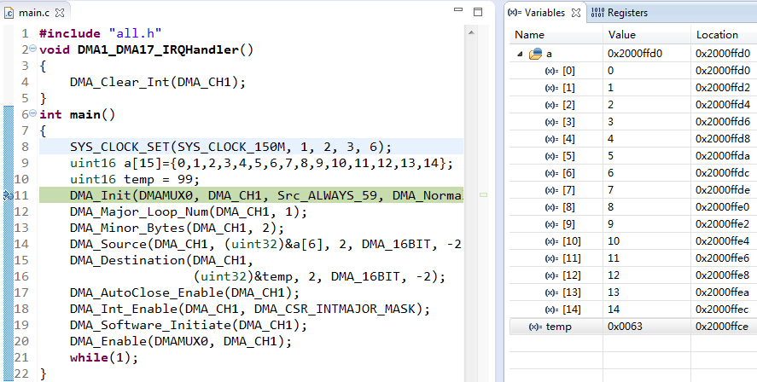

**执行后**

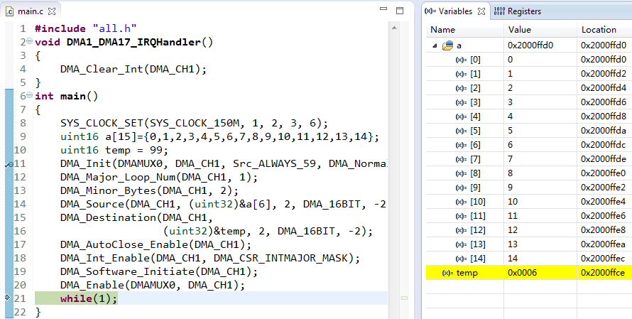

/****************** 1个uint32传输到1个uint32 ******************/

**#include** **"all.h"**

**int** **main**()

**{**

**SYS_CLOCK_SET(SYS_CLOCK_150M, 1, 2, 3, 6);**

uint32 **a[15]={0,1,2,3,4,5,6,7,8,9,10,11,12,13,14};**

uint32 **temp = 99;**

**DMA_Disable();**

**DMA_Init(DMAMUX0, DMA_CH1, Src_ALWAYS_59, DMA_Normal_Mode);**

**DMA_Major_Loop_Num(DMA_CH1, 1);**

**DMA_Minor_Bytes(DMA_CH1, 4);**

**DMA_Source(DMA_CH1, (**uint32**)&a[6], 4, DMA_32BIT, -4);**

**DMA_Destination(DMA_CH1,**

**(**uint32**)&temp, 4, DMA_32BIT, -4);**

**DMA_AutoClose_Enable(DMA_CH1);**

**DMA_Channal_Enable(DMA_CH1);**

**DMA_Enable();**

**DMA_Software_Initiate(DMA_CH1);**

**while(1);**

**}**

**The source-to-destination transfers are executed as follows:**

**1. Read byte from location (**uint32**)&a[6](在图中具体是0x2000ffcc), read byte from location (0x2000ffcc + 1), read byte from**

**(0x2000ffcc + 2), read byte from (0x2000ffcc + 3).**

**2. Write 32-bits to location (**uint32**)&temp(在图中具体是0x2000ffb0) → first iteration of the minor loop.**

**3. Major loop complete.**

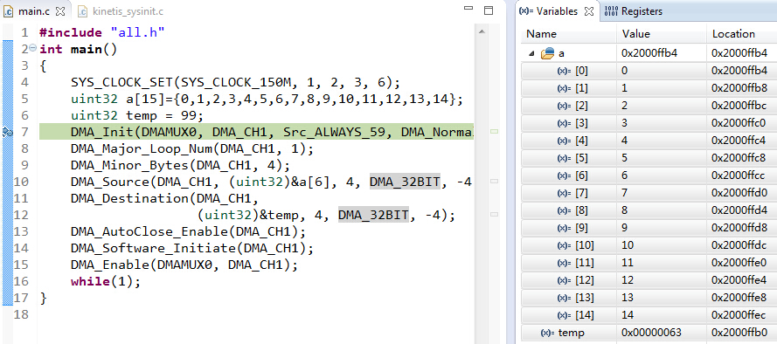

**执行后**

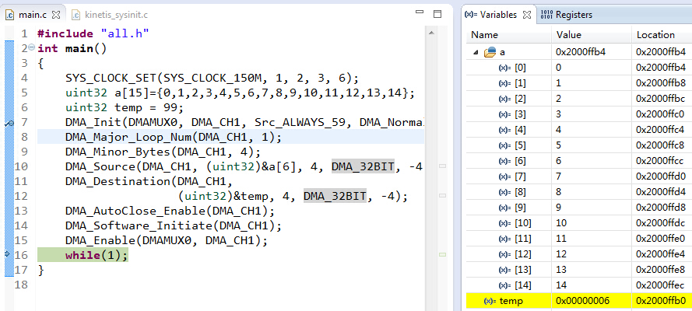

/******************* 2个uint32传输到2个uint32 *****************/

//01

**#include** **"all.h"**

**int** **main**()

**{**

**SYS_CLOCK_SET(SYS_CLOCK_150M, 1, 2, 3, 6);**

uint32 **a[15]={0,1,2,3,4,5,6,7,8,9,10,11,12,13,14};**

uint32 **temp = 99;**

**DMA_Disable();**

**DMA_Init(DMAMUX0, DMA_CH1, Src_ALWAYS_59, DMA_Normal_Mode);**

**DMA_Major_Loop_Num(DMA_CH1, 1);**

**DMA_Minor_Bytes(DMA_CH1, 8);**

**DMA_Source(DMA_CH1, (**uint32**)&a[6], 4, DMA_32BIT, -8);**

**DMA_Destination(DMA_CH1,**

**(**uint32**)&temp, 4, DMA_32BIT, -8);**

**DMA_AutoClose_Enable(DMA_CH1);**

**DMA_Channal_Enable(DMA_CH1);**

**DMA_Enable();**

**DMA_Software_Initiate(DMA_CH1);**

**while(1);**

**}**

**The source-to-destination transfers are executed as follows:**

**1. Read byte from location (**uint32**)&a[6](在图中具体是0x2000ffcc), read byte from location (0x2000ffcc + 1), read byte from**

**(0x2000ffcc + 2), read byte from (0x2000ffcc + 3).**

**2. Write 32-bits to location (**uint32**)&temp(在图中具体是0x2000ffb0) → first iteration of the minor loop.**

**3. Read byte from location (0x2000ffcc + 4), read byte from location (0x2000ffcc + 4), read byte from (0x2000ffcc + 5), read byte from (0x2000ffcc + 6).**

**4. Write 32-bits to location (0x2000ffb0 + 4)→ second iteration of the minor loop.**

**5. Major loop complete.**

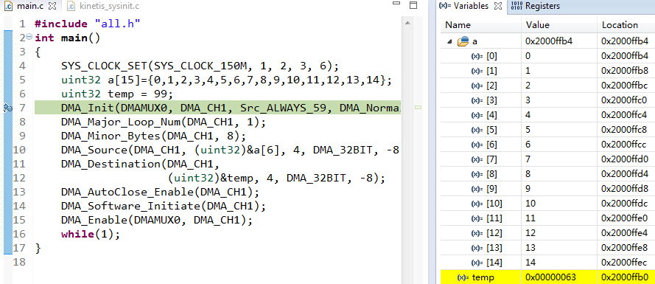

**执行后**

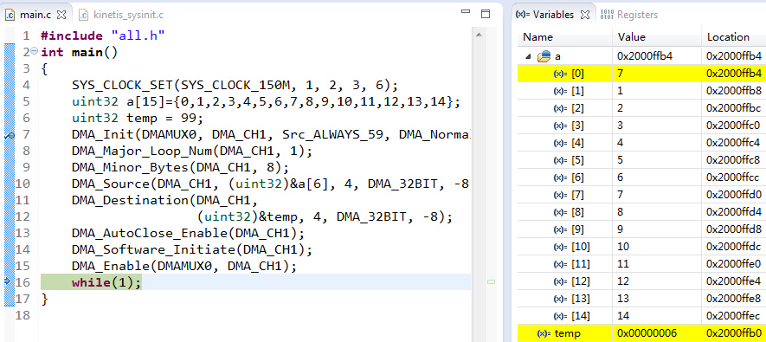

//02

**#include** **"all.h"**

**int** **main**()

**{**

**SYS_CLOCK_SET(SYS_CLOCK_150M, 1, 2, 3, 6);**

uint32 **a[15]={0,1,2,3,4,5,6,7,8,9,10,11,12,13,14};**

uint32 **temp = 99;**

**DMA_Disable();**

**DMA_Init(DMAMUX0, DMA_CH1, Src_ALWAYS_59, DMA_Normal_Mode);**

**DMA_Major_Loop_Num(DMA_CH1, 2);**

**DMA_Minor_Bytes(DMA_CH1, 4);**

**DMA_Source(DMA_CH1, (**uint32**)&a[6], 4, DMA_32BIT, -8);**

**DMA_Destination(DMA_CH1,**

**(**uint32**)&temp, 4, DMA_32BIT, -8);**

**DMA_AutoClose_Enable(DMA_CH1);**

**DMA_Channal_Enable(DMA_CH1);**

**DMA_Enable();**

**DMA_Software_Initiate(DMA_CH1);**

**while(1);**

**}**

**The source-to-destination transfers are executed as follows:**

**1. Read byte from location (**uint32**)&a[6](在图中具体是0x2000ffcc), read byte from location (0x2000ffcc + 1), read byte from**

**(0x2000ffcc + 2), read byte from (0x2000ffcc + 3).**

**2. Write 32-bits to location (**uint32**)&temp(在图中具体是0x2000ffb0) → first iteration of the minor loop.**

**3. Major loop Minus one**

**d. Read byte from location (0x2000ffcc + 4), read byte from location (0x2000ffcc + 4), read byte from (0x2000ffcc + 5), read byte from (0x2000ffcc + 6).**

**4. Write 32-bits to location (0x2000ffb0 + 4)→ second iteration of the minor loop.**

**5. Major loop complete.**

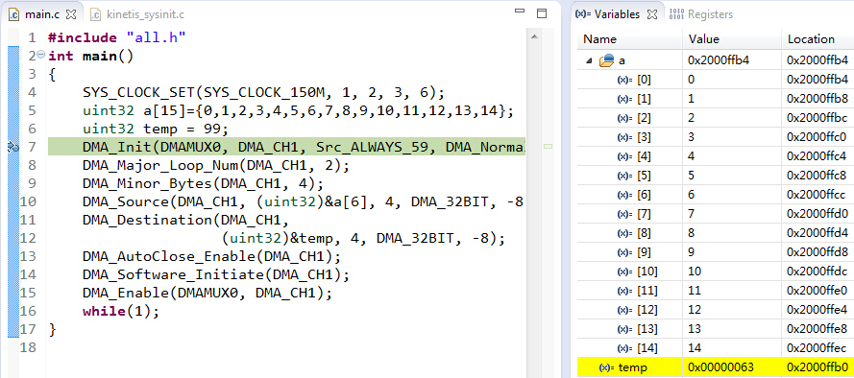

**执行后**

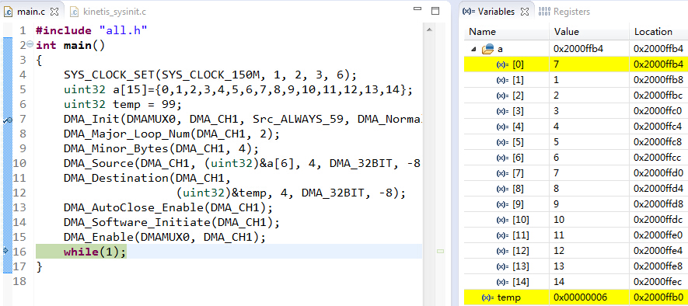

//03

**#include** **"all.h"**

**int** **main**()

**{**

**SYS_CLOCK_SET(SYS_CLOCK_150M, 1, 2, 3, 6);**

uint32 **a[15]={0,1,2,3,4,5,6,7,8,9,10,11,12,13,14};**

uint32 **temp = 99;**

**DMA_Disable();**

**DMA_Init(DMAMUX0, DMA_CH1, Src_ALWAYS_59, DMA_Normal_Mode);**

**DMA_Major_Loop_Num(DMA_CH1, 1);**

**DMA_Minor_Bytes(DMA_CH1, 8);**

**DMA_Source(DMA_CH1, (**uint32**)&a[6], 8, DMA_32BIT, -16);**

**DMA_Destination(DMA_CH1,**

**(**uint32**)&temp, 8, DMA_32BIT, -16);**

**DMA_AutoClose_Enable(DMA_CH1);**

**DMA_Channal_Enable(DMA_CH1);**

**DMA_Enable();**

**DMA_Software_Initiate(DMA_CH1);**

**while(1);**

**}**

**The source-to-destination transfers are executed as follows:**

**1. Read byte from location (**uint32**)&a[6](在图中具体是0x2000ffcc), read byte from location (0x2000ffcc + 1), read byte from**

**(0x2000ffcc + 2), read byte from (0x2000ffcc + 3).**

**2. Write 32-bits to location (**uint32**)&temp(在图中具体是0x2000ffb0) → first iteration of the minor loop.**

**3. Read byte from location (0x2000ffcc + 8), read byte from location (0x2000ffcc + 9), read byte from (0x2000ffcc + 10), read byte from (0x2000ffcc + 11).**

**4. Write 32-bits to location (0x2000ffb0 + 8)→ second iteration of the minor loop.**

**5. Major loop complete.**

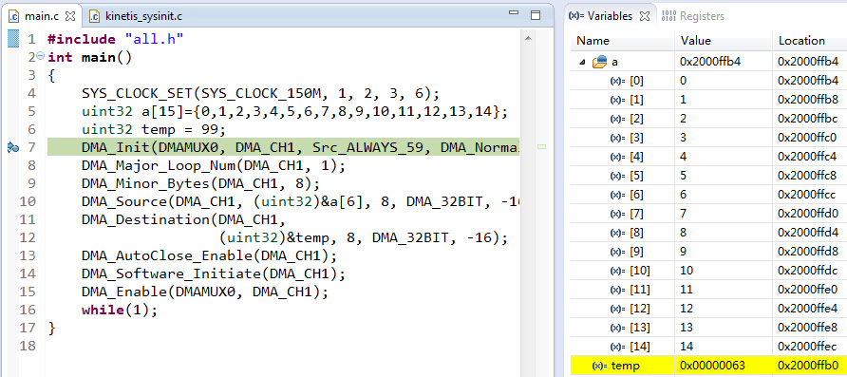

**执行后**

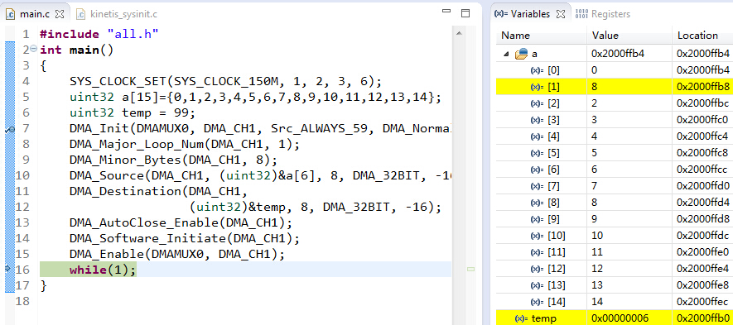

//04

**#include** **"all.h"**

**int** **main**()

**{**

**SYS_CLOCK_SET(SYS_CLOCK_150M, 1, 2, 3, 6);**

uint32 **a[15]={0,1,2,3,4,5,6,7,8,9,10,11,12,13,14};**

uint32 **temp = 99;**

**DMA_Disable();**

**DMA_Init(DMAMUX0, DMA_CH1, Src_ALWAYS_59, DMA_Normal_Mode);**

**DMA_Major_Loop_Num(DMA_CH1, 1);**

**DMA_Minor_Bytes(DMA_CH1, 8);**

**DMA_Source(DMA_CH1, (**uint32**)&a[6], 4, DMA_32BIT, -8);**

**DMA_Destination(DMA_CH1,**

**(**uint32**)&temp, 8, DMA_32BIT, -16);**

**DMA_AutoClose_Enable(DMA_CH1);**

**DMA_Channal_Enable(DMA_CH1);**

**DMA_Enable();**

**DMA_Software_Initiate(DMA_CH1);**

**while(1);**

**}**

**The source-to-destination transfers are executed as follows:**

**1. Read byte from location (**uint32**)&a[6](在图中具体是0x2000ffcc), read byte from location (0x2000ffcc + 1), read byte from**

**(0x2000ffcc + 2), read byte from (0x2000ffcc + 3).**

**2. Write 32-bits to location (**uint32**)&temp(在图中具体是0x2000ffb0) → first iteration of the minor loop.**

**3. Read byte from location (0x2000ffcc + 4), read byte from location (0x2000ffcc + 5), read byte from (0x2000ffcc + 6), read byte from (0x2000ffcc + 7).**

**4. Write 32-bits to location (0x2000ffb0 + 8)→ second iteration of the minor loop.**

**5. Major loop complete.**

**执行后**

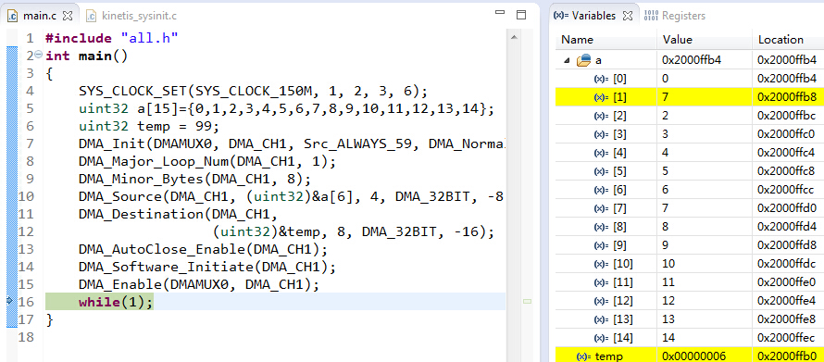

//05

**#include** **"all.h"**

**int** **main**()

**{**

**SYS_CLOCK_SET(SYS_CLOCK_150M, 1, 2, 3, 6);**

uint32 **a[15]={0,1,2,3,4,5,6,7,8,9,10,11,12,13,14};**

uint32 **temp = 99;**

**DMA_Disable();**

**DMA_Init(DMAMUX0, DMA_CH1, Src_ALWAYS_59, DMA_Normal_Mode);**

**DMA_Major_Loop_Num(DMA_CH1, 1);**

**DMA_Minor_Bytes(DMA_CH1, 8);**

**DMA_Source(DMA_CH1, (**uint32**)&a[6], 8, DMA_32BIT, -16);**

**DMA_Destination(DMA_CH1,**

**(**uint32**)&temp, 4, DMA_32BIT, -8);**

**DMA_AutoClose_Enable(DMA_CH1);**

**DMA_Channal_Enable(DMA_CH1);**

**DMA_Enable();**

**DMA_Software_Initiate(DMA_CH1);**

**while(1);**

**}**

**The source-to-destination transfers are executed as follows:**

**1. Read byte from location (**uint32**)&a[6](在图中具体是0x2000ffcc), read byte from location (0x2000ffcc + 1), read byte from**

**(0x2000ffcc + 2), read byte from (0x2000ffcc + 3).**

**2. Write 32-bits to location (**uint32**)&temp(在图中具体是0x2000ffb0) → first iteration of the minor loop.**

**3. Read byte from location (0x2000ffcc + 8), read byte from location (0x2000ffcc + 9), read byte from (0x2000ffcc + 10), read byte from (0x2000ffcc + 11).**

**4. Write 32-bits to location (0x2000ffb0 + 4)→ second iteration of the minor loop.**

**5. Major loop complete.**

**执行后**

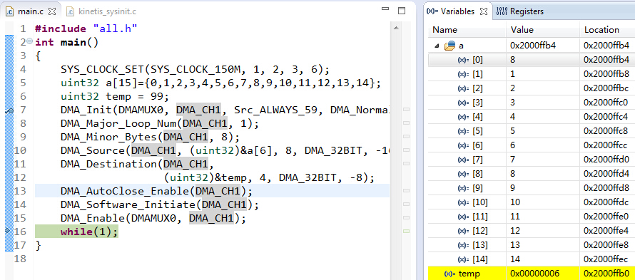

//06

**#include** **"all.h"**

**int** **main**()

**{**

**SYS_CLOCK_SET(SYS_CLOCK_150M, 1, 2, 3, 6);**

uint32 **a[15]={0,1,2,3,4,5,6,7,8,9,10,11,12,13,14};**

uint32 **temp = 99;**

**DMA_Disable();**

**DMA_Init(DMAMUX0, DMA_CH1, Src_ALWAYS_59, DMA_Normal_Mode);**

**DMA_Major_Loop_Num(DMA_CH1, 2);**

**DMA_Minor_Bytes(DMA_CH1, 4);**

**DMA_Source(DMA_CH1, (**uint32**)&a[6], 8, DMA_32BIT, -16);**

**DMA_Destination(DMA_CH1,**

**(**uint32**)&temp, 8, DMA_32BIT, -16);**

**DMA_AutoClose_Enable(DMA_CH1);**

**DMA_Channal_Enable(DMA_CH1);**

**DMA_Enable();**

**DMA_Software_Initiate(DMA_CH1);**

**while(1);**

**}**

**The source-to-destination transfers are executed as follows:**

**1. Read byte from location (**uint32**)&a[6](在图中具体是0x2000ffcc), read byte from location (0x2000ffcc + 1), read byte from**

**(0x2000ffcc + 2), read byte from (0x2000ffcc + 3).**

**2. Write 32-bits to location (**uint32**)&temp(在图中具体是0x2000ffb0) → first iteration of the minor loop.**

**3. Major loop Minus one**

**4. Read byte from location (0x2000ffcc + 8), read byte from location (0x2000ffcc + 9), read byte from (0x2000ffcc + 10), read byte from (0x2000ffcc + 11).**

**5. Write 32-bits to location (0x2000ffb0 + 8)→ second iteration of the minor loop.**

**6. Major loop complete.**

**执行后**

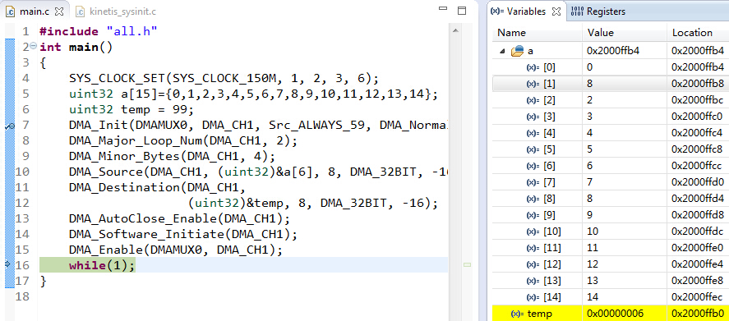

//07

**#include** **"all.h"**

**int** **main**()

**{**

**SYS_CLOCK_SET(SYS_CLOCK_150M, 1, 2, 3, 6);**

uint32 **a[15]={0,1,2,3,4,5,6,7,8,9,10,11,12,13,14};**

uint32 **temp = 99;**

**DMA_Disable();**

**DMA_Init(DMAMUX0, DMA_CH1, Src_ALWAYS_59, DMA_Normal_Mode);**

**DMA_Major_Loop_Num(DMA_CH1, 2);**

**DMA_Minor_Bytes(DMA_CH1, 4);**

**DMA_Source(DMA_CH1, (**uint32**)&a[6], 4, DMA_32BIT, -8);**

**DMA_Destination(DMA_CH1,**

**(**uint32**)&temp, 8, DMA_32BIT, -16);**

**DMA_AutoClose_Enable(DMA_CH1);**

**DMA_Channal_Enable(DMA_CH1);**

**DMA_Enable();**

**DMA_Software_Initiate(DMA_CH1);**

**while(1);**

**}**

**The source-to-destination transfers are executed as follows:**

**1. Read byte from location (**uint32**)&a[6](在图中具体是0x2000ffcc), read byte from location (0x2000ffcc + 1), read byte from**

**(0x2000ffcc + 2), read byte from (0x2000ffcc + 3).**

**2. Write 32-bits to location (**uint32**)&temp(在图中具体是0x2000ffb0) → first iteration of the minor loop.**

**3. Major loop Minus one**

**4. Read byte from location (0x2000ffcc + 4), read byte from location (0x2000ffcc + 4), read byte from (0x2000ffcc + 5), read byte from (0x2000ffcc + 6).**

**5. Write 32-bits to location (0x2000ffb0 + 8)→ second iteration of the minor loop.**

**6. Major loop complete.**

**执行后**

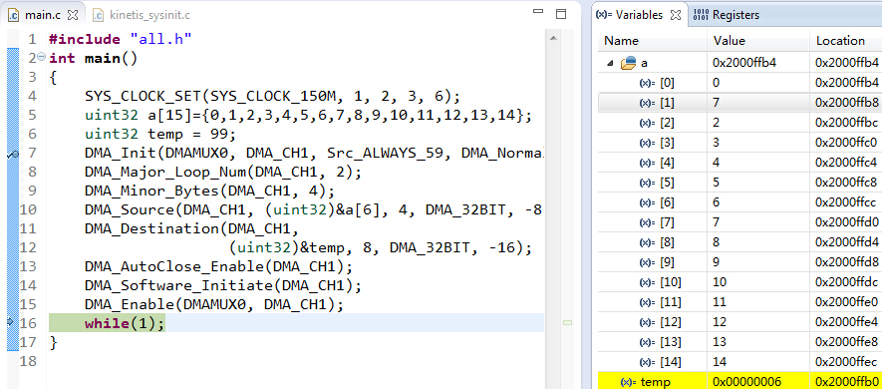

//08

**#include** **"all.h"**

**int** **main**()

**{**

**SYS_CLOCK_SET(SYS_CLOCK_150M, 1, 2, 3, 6);**

uint32 **a[15]={0,1,2,3,4,5,6,7,8,9,10,11,12,13,14};**

uint32 **temp = 99;**

**DMA_Disable();**

**DMA_Init(DMAMUX0, DMA_CH1, Src_ALWAYS_59, DMA_Normal_Mode);**

**DMA_Major_Loop_Num(DMA_CH1, 2);**

**DMA_Minor_Bytes(DMA_CH1, 4);**

**DMA_Source(DMA_CH1, (**uint32**)&a[6], 8, DMA_32BIT, -16);**

**DMA_Destination(DMA_CH1,**

**(**uint32**)&temp, 4, DMA_32BIT, -8);**

**DMA_AutoClose_Enable(DMA_CH1);**

**DMA_Channal_Enable(DMA_CH1);**

**DMA_Enable();**

**DMA_Software_Initiate(DMA_CH1);**

**while(1);**

**}**

**The source-to-destination transfers are executed as follows:**

**1. Read byte from location (**uint32**)&a[6](在图中具体是0x2000ffcc), read byte from location (0x2000ffcc + 1), read byte from**

**(0x2000ffcc + 2), read byte from (0x2000ffcc + 3).**

**2. Write 32-bits to location (**uint32**)&temp(在图中具体是0x2000ffb0) → first iteration of the minor loop.**

**3. Major loop Minus one**

**d. Read byte from location (0x2000ffcc + 8), read byte from location (0x2000ffcc + 9), read byte from (0x2000ffcc + 10), read byte from (0x2000ffcc + 11).**

**4. Write 32-bits to location (0x2000ffb0 + 4)→ second iteration of the minor loop.**

**5. Major loop complete.**

**执行后**

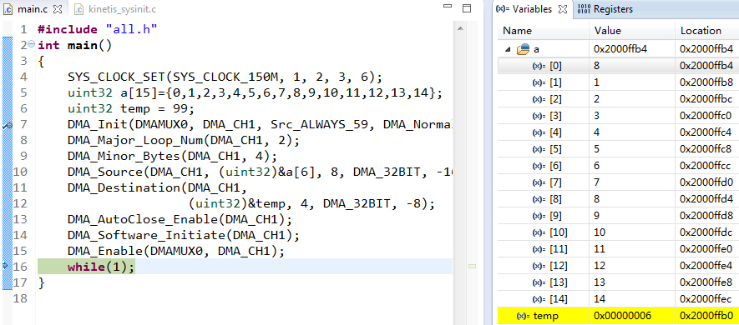

/****************** 3个uint32传输到3个uint32 ******************/

//01

**#include** **"all.h"**

**int** **main**()

**{**

**SYS_CLOCK_SET(SYS_CLOCK_150M, 1, 2, 3, 6);**

uint32 **a[15]={0,1,2,3,4,5,6,7,8,9,10,11,12,13,14};**

uint32 **temp = 99;**

**DMA_Disable();**

**DMA_Init(DMAMUX0, DMA_CH1, Src_ALWAYS_59, DMA_Normal_Mode);**

**DMA_Major_Loop_Num(DMA_CH1, 1);**

**DMA_Minor_Bytes(DMA_CH1, 12);**

**DMA_Source(DMA_CH1, (**uint32**)&a[6], 4, DMA_32BIT, -12);**

**DMA_Destination(DMA_CH1,**

**(**uint32**)&temp, 4, DMA_32BIT, -12);**

**DMA_AutoClose_Enable(DMA_CH1);**

**DMA_Channal_Enable(DMA_CH1);**

**DMA_Enable();**

**DMA_Software_Initiate(DMA_CH1);**

**while(1);**

**}**

**The source-to-destination transfers are executed as follows:**

**1. Read byte from location (**uint32**)&a[6](在图中具体是0x2000ffcc), read byte from location (0x2000ffcc + 1), read byte from (0x2000ffcc + 2), read byte from (0x2000ffcc + 3).**

**2. Write 32-bits to location (**uint32**)&temp(在图中具体是0x2000ffb0) → first iteration of the minor loop.**

**3. Read byte from location (0x2000ffcc + 4), read byte from location (0x2000ffcc + 4), read byte from (0x2000ffcc + 5), read byte from (0x2000ffcc + 6).**

**4. Write 32-bits to location (0x2000ffb0 + 4)→ second iteration of the minor loop.**

**5. Read byte from location (0x2000ffcc + 8), read byte from location (0x2000ffcc + 9), read byte from (0x2000ffcc + 10), read byte from (0x2000ffcc + 11).**

**6. Write 32-bits to location (0x2000ffb0 + 8)→ second iteration of the minor loop.**

**7. Major loop complete.**

**执行后**

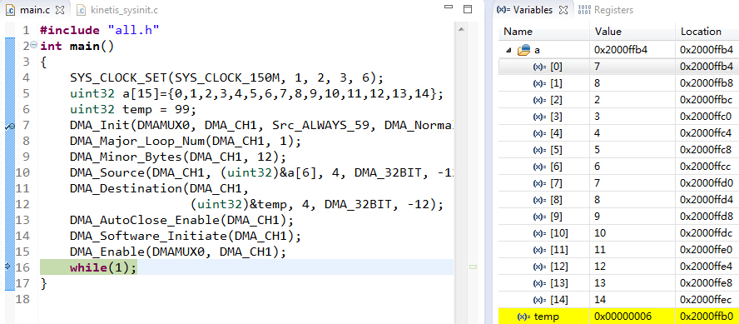

//02

**#include** **"all.h"**

**int** **main**()

**{**

**SYS_CLOCK_SET(SYS_CLOCK_150M, 1, 2, 3, 6);**

uint32 **a[15]={0,1,2,3,4,5,6,7,8,9,10,11,12,13,14};**

uint32 **temp = 99;**

**DMA_Disable();**

**DMA_Init(DMAMUX0, DMA_CH1, Src_ALWAYS_59, DMA_Normal_Mode);**

**DMA_Major_Loop_Num(DMA_CH1, 3);**

**DMA_Minor_Bytes(DMA_CH1, 4);**

**DMA_Source(DMA_CH1, (**uint32**)&a[6], 4, DMA_32BIT, -12);**

**DMA_Destination(DMA_CH1,**

**(**uint32**)&temp, 4, DMA_32BIT, -12);**

**DMA_AutoClose_Enable(DMA_CH1);**

**DMA_Channal_Enable(DMA_CH1);**

**DMA_Enable();**

**DMA_Software_Initiate(DMA_CH1);**

**while(1);**

**}**

**The source-to-destination transfers are executed as follows:**

**1. Read byte from location (**uint32**)&a[6](在图中具体是0x2000ffcc), read byte from location (0x2000ffcc + 1), read byte from (0x2000ffcc + 2), read byte from (0x2000ffcc + 3).**

**2. Write 32-bits to location (**uint32**)&temp(在图中具体是0x2000ffb0) → first iteration of the minor loop.**

**3. Major loop Minus one.**

**4. Read byte from location (0x2000ffcc + 4, read byte from location (0x2000ffcc + 5), read byte from (0x2000ffcc + 6), read byte from (0x2000ffcc + 7).**

**5. Write 32-bits to location (0x2000ffb0 + 4)→ second iteration of the minor loop.**

**6. Major loop Minus one again.**

**7. Read byte from location (0x2000ffcc + 8), read byte from location (0x2000ffcc + 9), read byte from (0x2000ffcc + 10), read byte from (0x2000ffcc + 11).**

**8. Write 32-bits to location (0x2000ffb0 + 8)→ second iteration of the minor loop.**

**9. Major loop complete.**

**执行后**

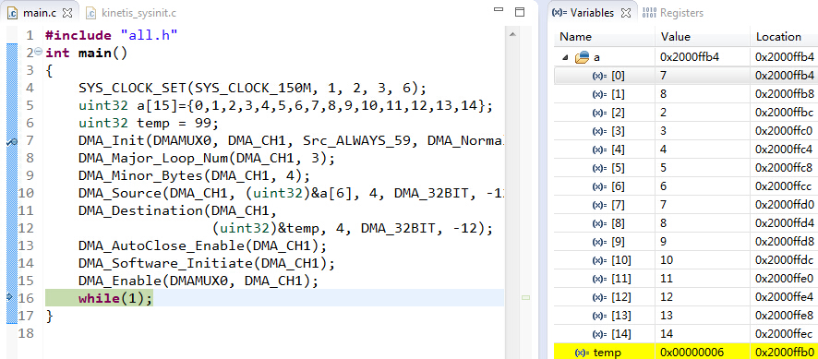

**/**************** 不同类型变量的传输 *****************/**

/****************** 1个uint16传输到1个uint32 ******************/

**#include** **"all.h"**

**int** **main**()

**{**

**SYS_CLOCK_SET(SYS_CLOCK_150M, 1, 2, 3, 6);**

uint16 **a[15]={0,1,2,3,4,5,6,7,8,9,10,11,12,13,14};**

uint32 **temp = 99;**

**DMA_Disable();**

**DMA_Init(DMAMUX0, DMA_CH1, Src_ALWAYS_59, DMA_Normal_Mode);**

**DMA_Major_Loop_Num(DMA_CH1, 1);**

**DMA_Minor_Bytes(DMA_CH1, 2);**

**DMA_Source(DMA_CH1, (**uint32**)&a[6], 2, DMA_16BIT, -2);**

**DMA_Destination(DMA_CH1,**

**(**uint32**)&temp, 4, DMA_16BIT, -4);**

**DMA_AutoClose_Enable(DMA_CH1);**

**DMA_Channal_Enable(DMA_CH1);**

**DMA_Enable();**

**DMA_Software_Initiate(DMA_CH1);**

**while(1);**

**}**

**The source-to-destination transfers are executed as follows:**

**1. Read byte from location (**uint32**)&a[6](在图中具体是0x2000ffdc), read byte from location (0x2000ffdc + 1).**

**2. Write 16-bits to location (**uint32**)&temp(在图中具体是0x2000ffcc) → first iteration of the minor loop.**

**3. Major loop complete.**

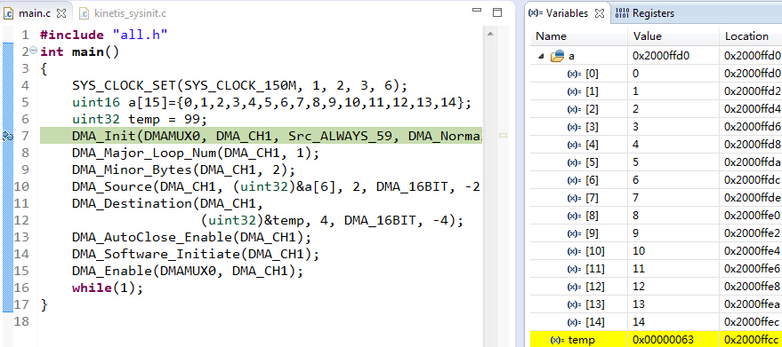

**执行后**

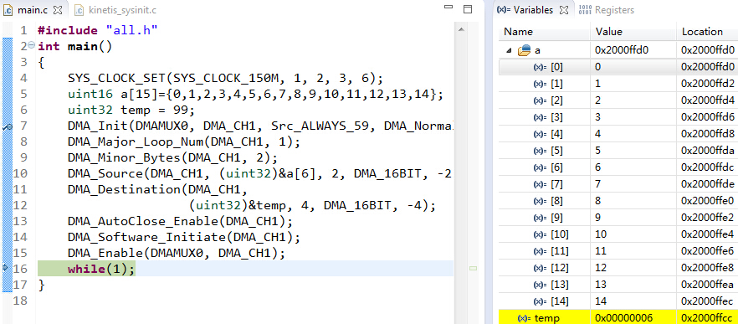

/***************** 2个uint16传输到1个uint32 ******************/

**#include** **"all.h"**

**int** **main**()

**{**

**SYS_CLOCK_SET(SYS_CLOCK_150M, 1, 2, 3, 6);**

uint16 **a[15]={0,1,2,3,4,5,6,7,8,9,10,11,12,13,14};**

uint32 **temp = 99;**

**DMA_Disable();**

**DMA_Init(DMAMUX0, DMA_CH1, Src_ALWAYS_59, DMA_Normal_Mode);**

**DMA_Major_Loop_Num(DMA_CH1, 1);**

**DMA_Minor_Bytes(DMA_CH1, 4);**

**DMA_Source(DMA_CH1, (**uint32**)&a[6], 2, DMA_16BIT, -4);**

**DMA_Destination(DMA_CH1,**

**(**uint32**)&temp, 4, DMA_32BIT, -4);**

**DMA_AutoClose_Enable(DMA_CH1);**

**DMA_Channal_Enable(DMA_CH1);**

**DMA_Enable();**

**DMA_Software_Initiate(DMA_CH1);**

**while(1);**

**}**

**The source-to-destination transfers are executed as follows:**

**1. Read byte from location (**uint32**)&a[6](在图中具体是0x2000ffdc), read byte from location (0x2000ffdc + 1), read byte from(0x2000ffdc + 2), read byte from (0x2000ffdc + 3).**

**2. Write 32-bits to location (**uint32**)&temp(在图中具体是0x2000ffcc) → first iteration of the minor loop.**

**3. Major loop complete.**

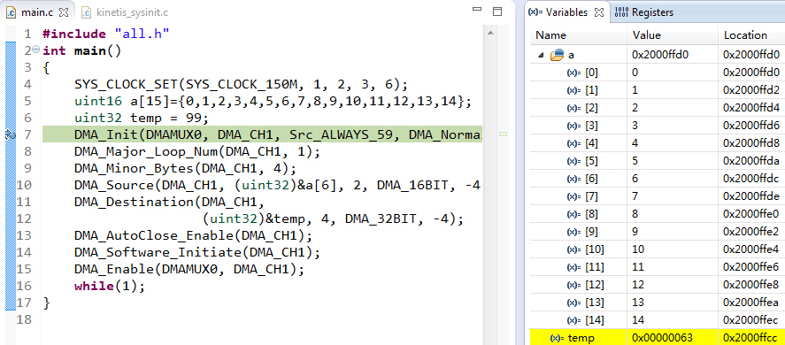

**执行后**

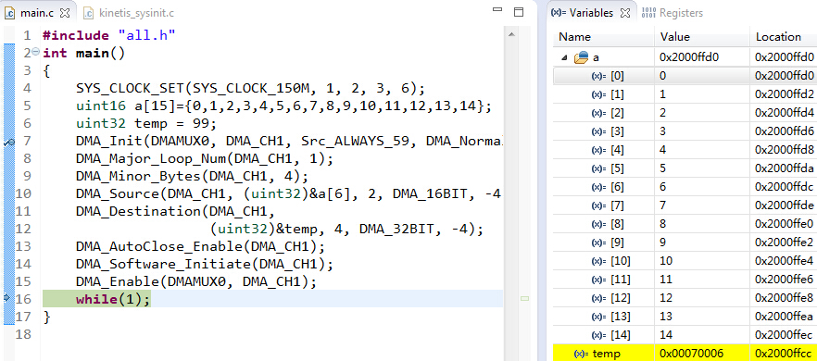

/***************** 2个uint16传输到2个uint32 ******************/

**#include** **"all.h"**

**int** **main**()

**{**

**SYS_CLOCK_SET(SYS_CLOCK_150M, 1, 2, 3, 6);**

uint16 **a[15]={0,1,2,3,4,5,6,7,8,9,10,11,12,13,14};**

uint32 **temp = 99;**

**DMA_Disable();**

**DMA_Init(DMAMUX0, DMA_CH1, Src_ALWAYS_59, DMA_Normal_Mode);**

**DMA_Major_Loop_Num(DMA_CH1, 1);**

**DMA_Minor_Bytes(DMA_CH1, 4);**

**DMA_Source(DMA_CH1, (**uint32**)&a[6], 2, DMA_16BIT, -4);**

**DMA_Destination(DMA_CH1,**

**(**uint32**)&temp, 4, DMA_16BIT, -4);**

**DMA_AutoClose_Enable(DMA_CH1);**

**DMA_Channal_Enable(DMA_CH1);**

**DMA_Enable();**

**DMA_Software_Initiate(DMA_CH1);**

**while(1);**

**}**

**The source-to-destination transfers are executed as follows:**

**1. Read byte from location (**uint32**)&a[6](在图中具体是0x2000ffdc), read byte from location (0x2000ffdc + 1).**

**2. Write 16-bits to location (**uint32**)&temp(在图中具体是0x2000ffcc) → first iteration of the minor loop.**

**3. Read byte from location (0x2000ffdc + 2), read byte from location (0x2000ffdc + 3).**

**4. Write 16-bits to location (0x2000ffcc + 4)→ second iteration of the minor loop.**

**5. Major loop complete.**

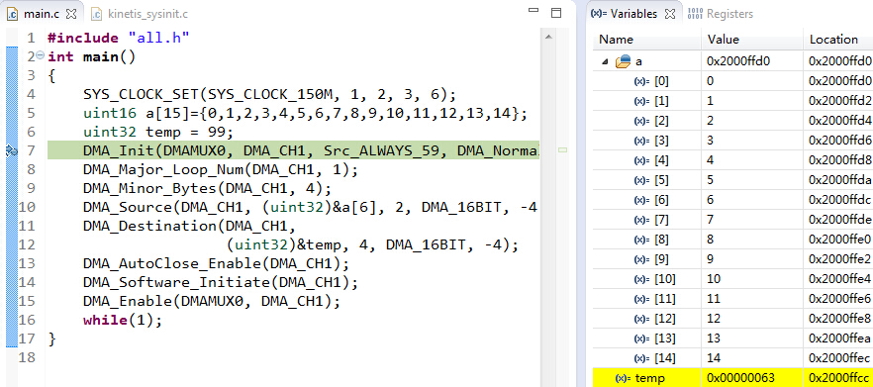

**执行后**

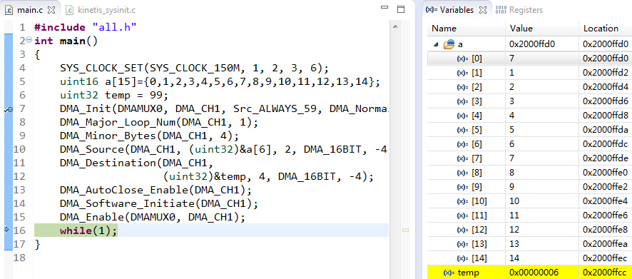

**/**************** 内存到寄存器 ***************/**

我感觉原理都是一样的,不想写

**/********** DMA_Channal_Enable(DMA_CH1); *********/**

**#include** **"all.h"**

**int** **main**()

**{**

**SYS_CLOCK_SET(SYS_CLOCK_150M, 1, 2, 3, 6);**

uint32 **a[15]={0,1,2,3,4,5,6,7,8,9,10,11,12,13,14};**

uint32 **temp = 99;**

**DMA_Disable();**

**DMA_Init(DMAMUX0, DMA_CH1, Src_ALWAYS_59, DMA_Normal_Mode);**

**DMA_Major_Loop_Num(DMA_CH1, 3);**

**DMA_Minor_Bytes(DMA_CH1, 8);**

**DMA_Source(DMA_CH1, (**uint32**)&a[6], 4, DMA_32BIT, -8);**

**DMA_Destination(DMA_CH1,**

**(**uint32**)&temp, 4, DMA_32BIT, -8);**

**DMA_AutoClose_Enable(DMA_CH1);**

//DMA_Channal_Enable(DMA_CH1);

**DMA_Enable();**

**DMA_Software_Initiate(DMA_CH1);**

**while(1);**

**}**

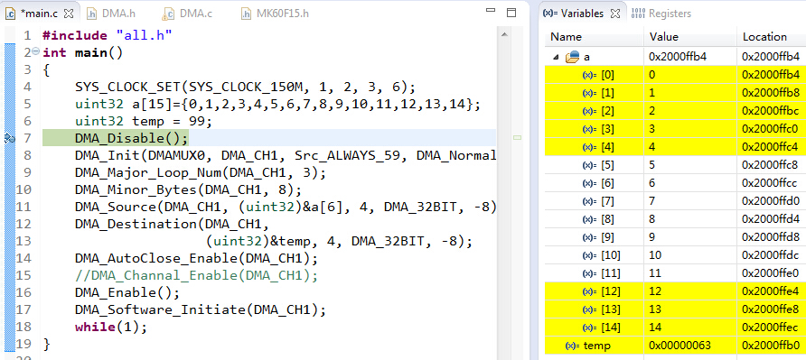

**执行后**

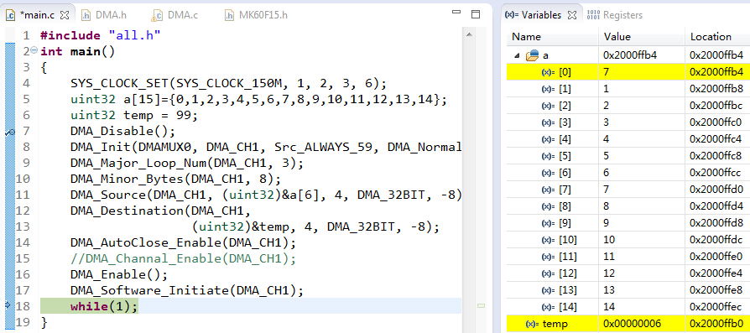

**把注释去掉之后**

**#include** **"all.h"**

**int** **main**()

**{**

**SYS_CLOCK_SET(SYS_CLOCK_150M, 1, 2, 3, 6);**

uint32 **a[15]={0,1,2,3,4,5,6,7,8,9,10,11,12,13,14};**

uint32 **temp = 99;**

**DMA_Disable();**

**DMA_Init(DMAMUX0, DMA_CH1, Src_ALWAYS_59, DMA_Normal_Mode);**

**DMA_Major_Loop_Num(DMA_CH1, 3);**

**DMA_Minor_Bytes(DMA_CH1, 8);**

**DMA_Source(DMA_CH1, (**uint32**)&a[6], 4, DMA_32BIT, -8);**

**DMA_Destination(DMA_CH1,**

**(**uint32**)&temp, 4, DMA_32BIT, -8);**

**DMA_AutoClose_Enable(DMA_CH1);**

**DMA_Channal_Enable(DMA_CH1);**

**DMA_Enable();**

**DMA_Software_Initiate(DMA_CH1);**

**while(1);**

**}**

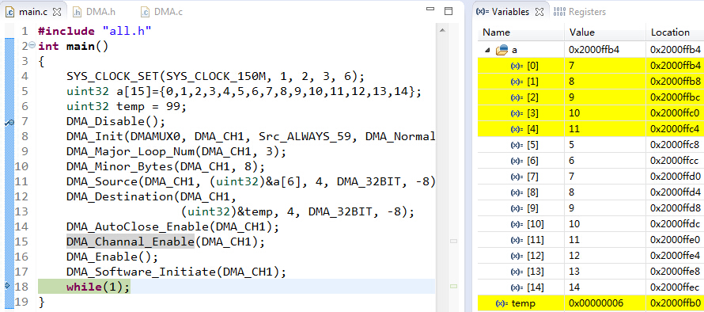

**/********* DMA_AutoClose_Disable(DMA_CH1);********/**

**#include** **"all.h"**

**int** **main**()

**{**

**SYS_CLOCK_SET(SYS_CLOCK_150M, 1, 2, 3, 6);**

uint32 **a[15]={0,1,2,3,4,5,6,7,8,9,10,11,12,13,14};**

uint32 **temp = 99;**

**DMA_Disable();**

**DMA_Init(DMAMUX0, DMA_CH1, Src_ALWAYS_59, DMA_Normal_Mode);**

**DMA_Major_Loop_Num(DMA_CH1, 3);**

**DMA_Minor_Bytes(DMA_CH1, 8);**

**DMA_Source(DMA_CH1, (**uint32**)&a[6], 4, DMA_32BIT, -8);**

**DMA_Destination(DMA_CH1,**

**(**uint32**)&temp, 4, DMA_32BIT, -8);**

**DMA_AutoClose_Enable(DMA_CH1);**

**DMA_Channal_Enable(DMA_CH1);**

**DMA_Enable();**

**DMA_Software_Initiate(DMA_CH1);**

**while(1);**

**}**

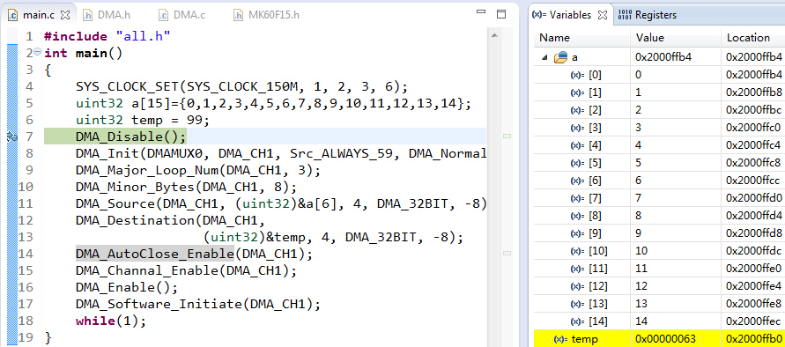

**执行后**



**换成DMA_AutoClose_Disable(DMA_CH1);之后**

**#include** **"all.h"**

**int** **main**()

**{**

**SYS_CLOCK_SET(SYS_CLOCK_150M, 1, 2, 3, 6);**

uint32 **a[15]={0,1,2,3,4,5,6,7,8,9,10,11,12,13,14};**

uint32 **temp = 99;**

**DMA_Disable();**

**DMA_Init(DMAMUX0, DMA_CH1, Src_ALWAYS_59, DMA_Normal_Mode);**

**DMA_Major_Loop_Num(DMA_CH1, 3);**

**DMA_Minor_Bytes(DMA_CH1, 8);**

**DMA_Source(DMA_CH1, (**uint32**)&a[6], 4, DMA_32BIT, -8);**

**DMA_Destination(DMA_CH1,**

**(**uint32**)&temp, 4, DMA_32BIT, -8);**

//DMA_AutoClose_Enable(DMA_CH1);

**DMA_AutoClose_Disable(DMA_CH1);**

**DMA_Channal_Enable(DMA_CH1);**

**DMA_Enable();**

**DMA_Software_Initiate(DMA_CH1);**

**while(1);**

**}**

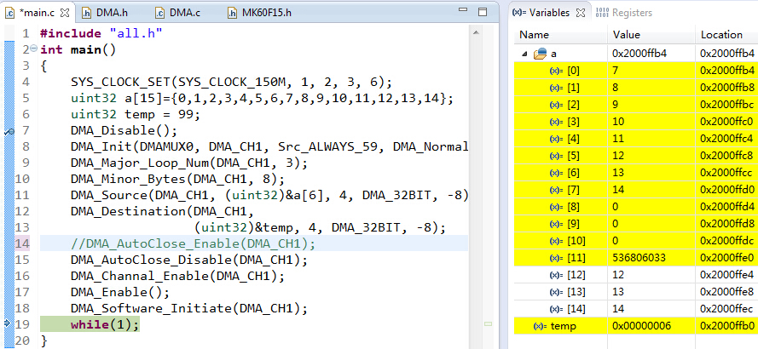

**/******************* 中断 ***********************/**

**#include** **"all.h"**

**void** **DMA1_DMA17_IRQHandler**()

**{**

**DMA_Clear_Int(DMA_CH1);**

**}**

**int** **main**()

**{**

**SYS_CLOCK_SET(SYS_CLOCK_150M, 1, 2, 3, 6);**

uint8 **a[15]={0,1,2,3,4,5,6,7,8,9,10,11,12,13,14};**

uint8 **temp = 99;**

**DMA_Disable();**

**DMA_Init(DMAMUX0, DMA_CH1, Src_ALWAYS_59, DMA_Normal_Mode);**

**DMA_Major_Loop_Num(DMA_CH1, 1);**

**DMA_Minor_Bytes(DMA_CH1, 1);**

**DMA_Source(DMA_CH1, (**uint32**)&a[6], 1, DMA_8BIT, -1);**

**DMA_Destination(DMA_CH1, (**uint32**)&temp, 1, DMA_32BIT, -1);**

**DMA_AutoClose_Enable(DMA_CH1);**

**DMA_Int_Enable(DMA_CH1, DMA_CSR_INTMAJOR_MASK);**

**DMA_Channal_Enable(DMA_CH1);**

**DMA_Enable();**

**DMA_Software_Initiate(DMA_CH1);**

**while(1);**

**}**

**/************************* END of DMA例程 ***************************/**